## **Health insurance cross sell prediction**

**Capstone Project Using Classification**

**Monica Patel**

**(Data science Enthusiast at Alma Better Pro Member Bangalore)**

**Abstract**

Our client is an Insurance company that has provided Health Insurance to its customers now they need your help in building a model to predict whether the policyholders (customers) from past year will also be interested in Vehicle Insurance provided by the company.

An insurance policy is an arrangement by which a company undertakes to provide a guarantee of compensation for specified loss, damage, illness, or death in return for the payment of a specified premium. A premium is a sum of money that the customer needs to pay regularly to an insurance company for this guarantee.

For example, you may pay a premium of Rs. 5000 each year for a health insurance cover of Rs. 200,000/- so that if, God forbid, you fall ill and need to be hospitalised in that year, the insurance provider company will bear the cost of hospitalisation etc. for upto Rs. 200,000. Now if you are wondering how can company bear such high hospitalisation cost when it charges a premium of only Rs. 5000/-, that is where the concept of probabilities comes in picture. For example, like you, there may be 100 customers who would be paying a premium of Rs. 5000 every year, but only a few of them (say 2-3) would get hospitalised that year and not everyone. This way everyone shares the risk of everyone else.

Just like medical insurance, there is vehicle insurance where every year customer needs to pay a premium of certain amount to insurance provider company so that in case of unfortunate accident by the vehicle, the insurance provider company will provide a compensation (called ‘sum assured’) to the customer.

Building a model to predict whether a customer would be interested in Vehicle Insurance is extremely helpful for the company because it can then accordingly plan its communication strategy to reach out to those customers and optimise its business model and revenue.

Now, in order to predict, whether the customer would be interested in Vehicle insurance, you have information about demographics (gender, age, region code type), Vehicles (Vehicle Age, Damage), Policy (Premium, sourcing channel) etc.

## **Data Description**

| **Variable** | **Definition** |
| --- | --- |
| id | Unique ID for the customer |
| Gender | Gender of the customer |
| Age | Age of the customer |
| Driving_License | 0 : Customer does not have DL, 1 : Customer already has DL |
| Region_Code | Unique code for the region of the customer |
| Previously_Insured | 1 : Customer already has Vehicle Insurance, 0 : Customer doesn't have Vehicle Insurance |
| Vehicle_Age | Age of the Vehicle |
| Vehicle_Damage | 1 : Customer got his/her vehicle damaged in the past. 0 : Customer didn't get his/her vehicle damaged in the past. |
| Annual_Premium | The amount customer needs to pay as premium in the year |
| Policy_Sales_Channel | Anonymized Code for the channel of outreaching to the customer ie. Different Agents, Over Mail, Over Phone, In Person, etc. |
| Vintage | Number of Days, Customer has been associated with the company |
| Response | 1 : Customer is interested, 0 : Customer is not interested |

**Introduction**

* insurance is a contract, represented by a policy, in which an individual or entity receives financial protection or reimbursement against losses from an insurance company.
* This EDA will use Python libraries, matplotlib, and Seaborn to examine the Subscribed health insurance customers dataset through visualizations and graphs.
* The dataset is of Subscribed Health insurance customers from insurance companies, contains information such asAge, Gender, Driving Licence, Region Etc.
* Machine learning has a wide range of applications in our organization. Prediction and analysis have long been the most well-known application of machine learning, which fuels our sale prediction.
* We're also utilizing machine learning to assist in designing our Sale strategies and Campaign programmes by identifying traits that lead to successful content.
* We utilize it to help Companies to rapidly expand their reach to customers with appropriate data driven decisions.
* We can also employ machine learning to improve Service and Customer retention, Target oriented promotions.

Our major goal in this project is to identify Customers who are interested in purchasing vehicle insurance based on subscribed health insurance data of the company

**1. Exploratory Data Analysis:**

**a. Understanding the data-** In this step after loading the data I performed head, tail, columns, info, dtypes, describe functions to get basic information about our dataset.

**b. Checking for missing & duplicated values-** Then I checked for missing values in our dataset using is null function. Some of our features had missing values that I filled with ‘unknown’

**2. Data Visualization**

**4. EDA:**

* **Observing and Exploring Dataset**

Exploratory data analysis is a method with help of this we can understand dataset, we can create some insights from data. We can understand statistics part of the data like mean, mode etc.

With EDA we can find null values, missing values, duplicate in the data set and outliers. We can find correlation between features in dataset. In EDA we can perform various data visualization method on data and observe what is happening in data.

After observing the data, we would say that

there are 12 columns and 381109 rows

## Response type:

* 1. Interested
  2. Not Interested

Segregation of customers according to their interest is first step towards the building of prediction model, we have features like age, vehicle age, and annual premium of the policy taken. These features have a correlation with response variable.

### Null values Treatment

While reading data in the analytical tool (Python Google Colab) we found that we do not have any missing value in the dataset hence we have not done anything in Null value treatment process.

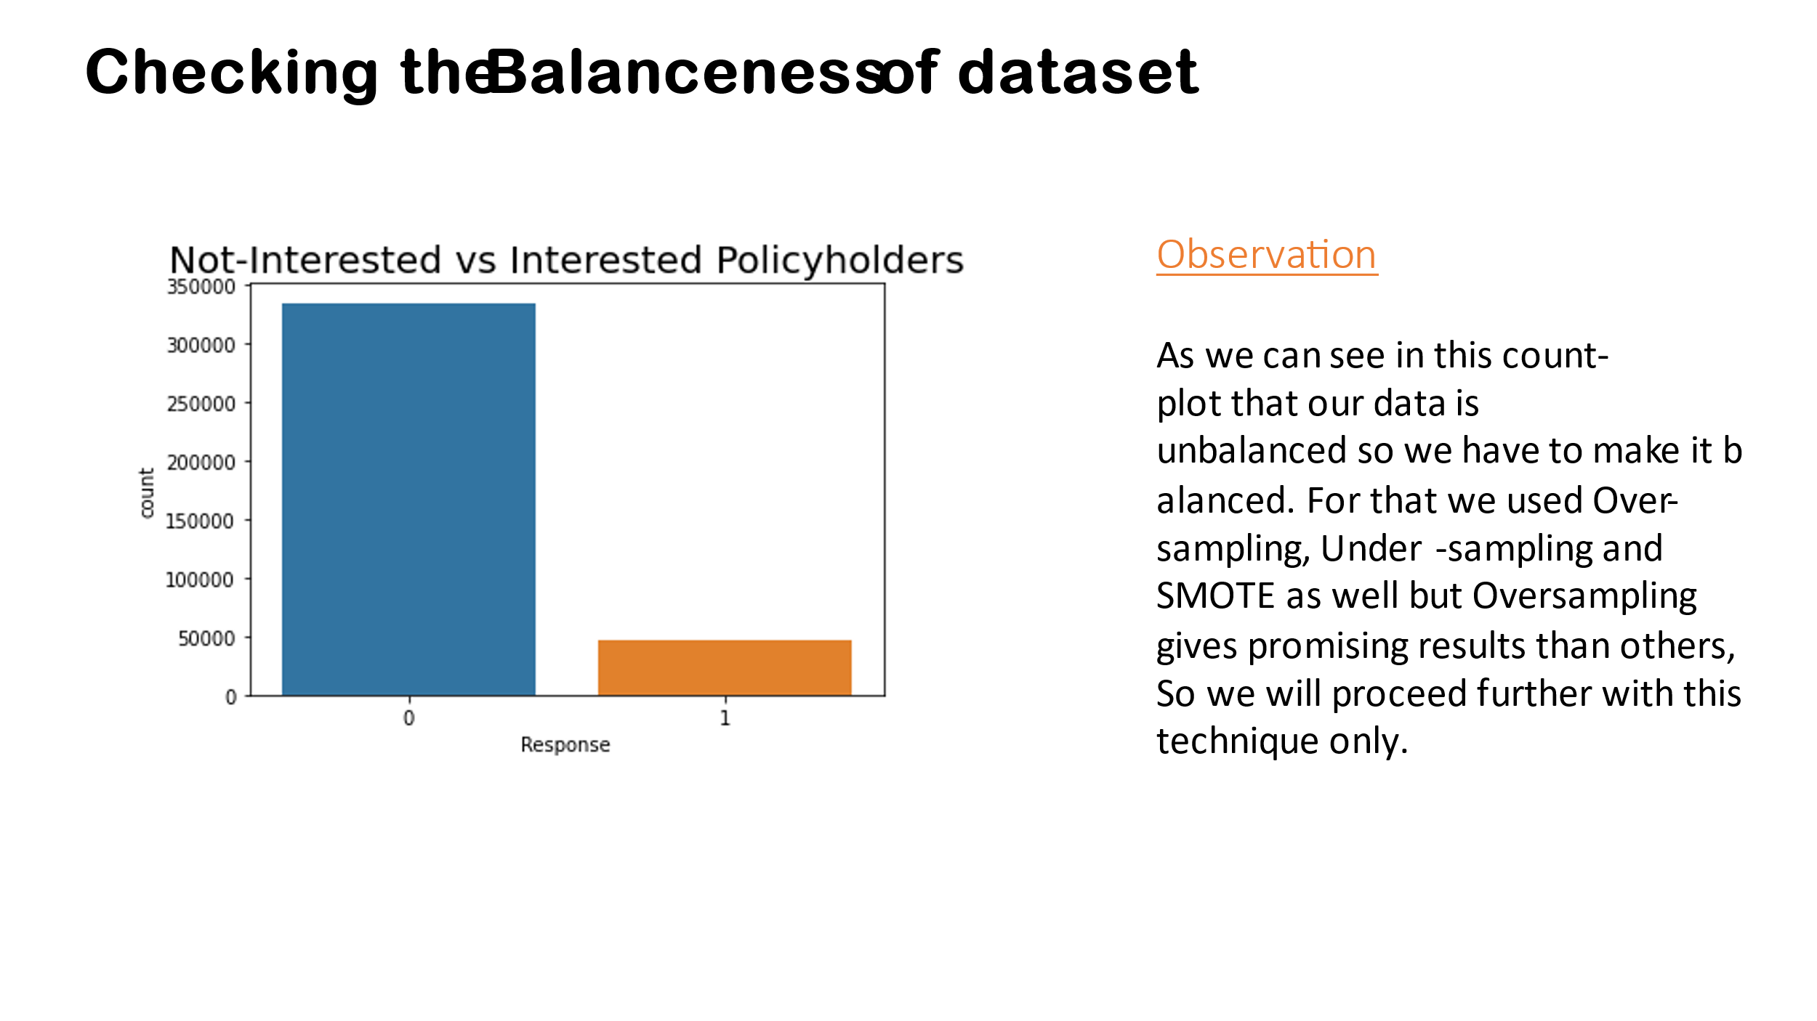

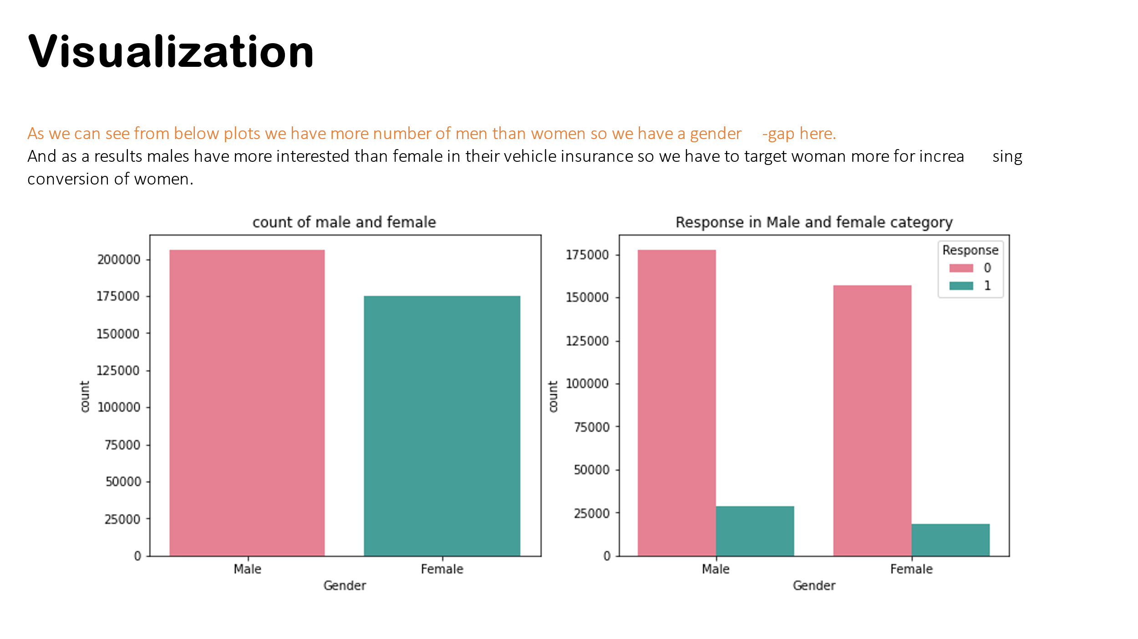

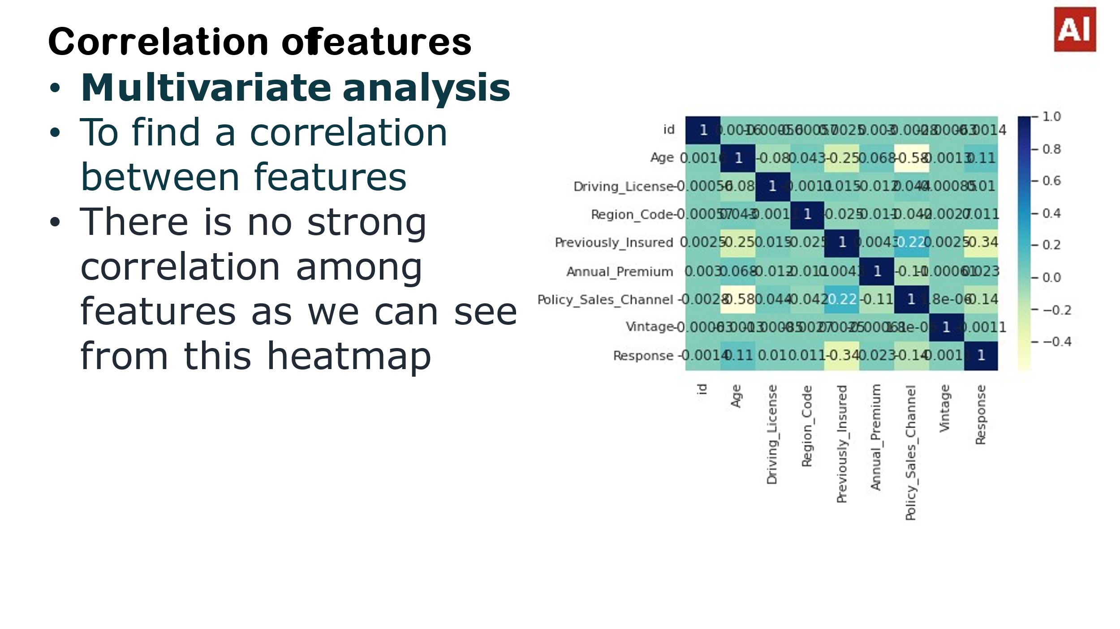

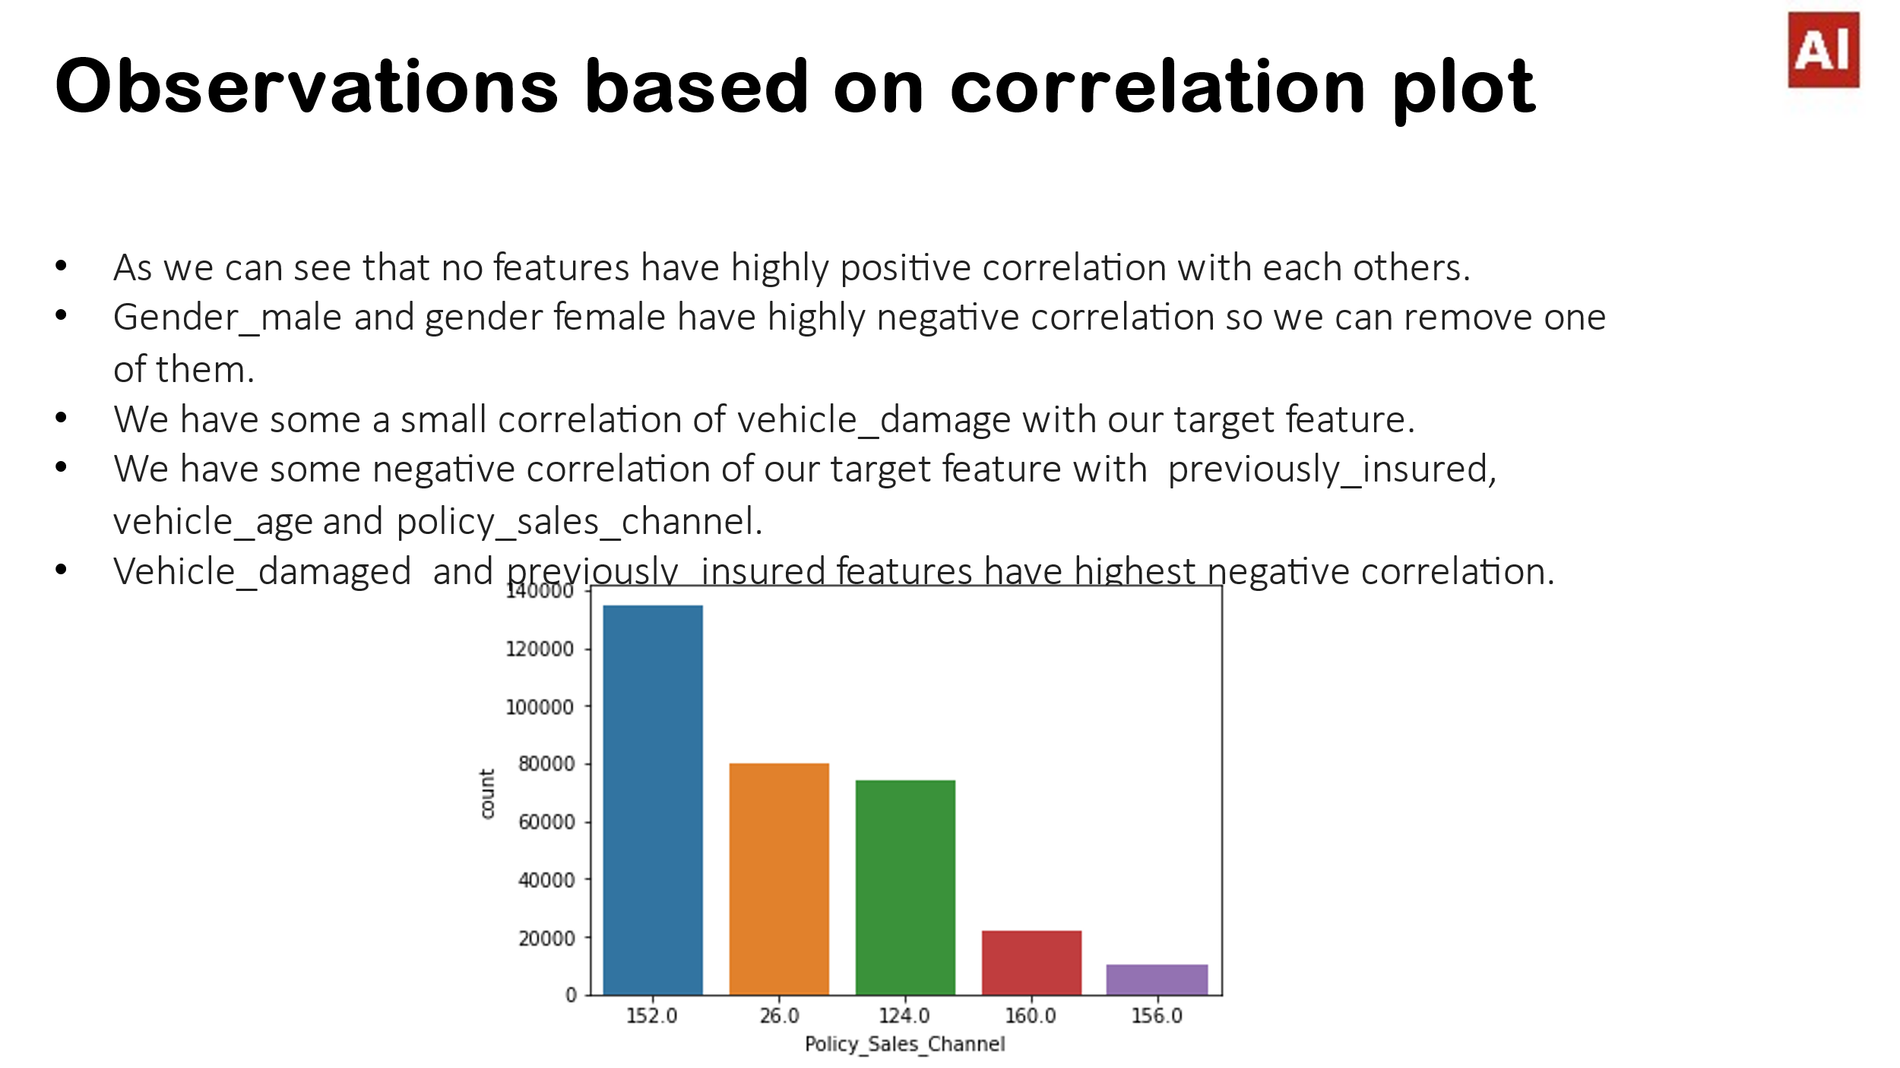

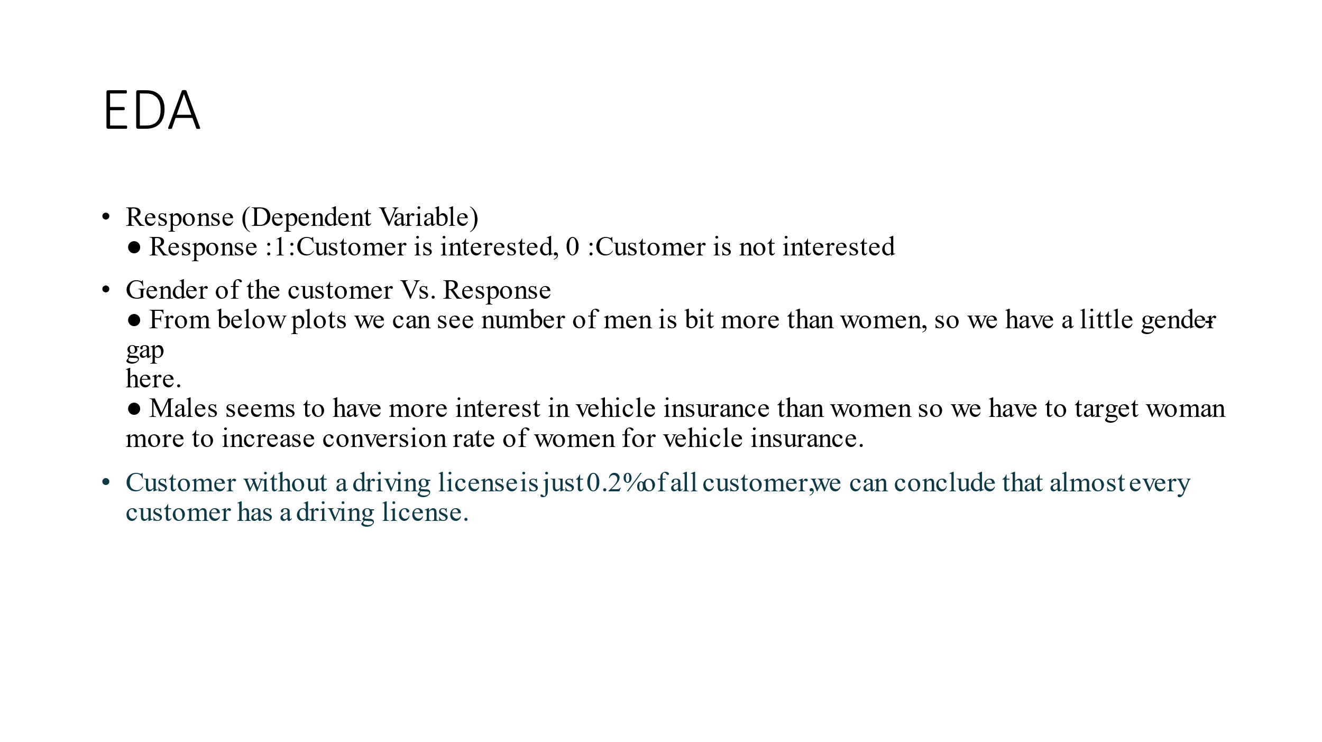

## Response type:

* 1. Interested
  2. Not Interested

Segregation of customers according to their interest is first step towards the building of prediction model, we have features like age, vehicle age, and annual premium of the policy taken. These features have a correlation with response variable.

4. Driving_License 0: Customer does not have DL, 1: Customer already has DL

5. Region_Code: Unique code for the region of the customer

6. Previously_Insured: 1: Customer already has Vehicle Insurance, 0: Customer doesn't have Vehicle Insurance

7. Vehicle Age:  Age of the Vehicle

8. Vehicle_Damage :1: Customer got his/her vehicle damaged in the past. 0: Customer didn't get his/her vehicle damaged in the past.

9. Annual_Premium: The amount customer needs to pay as premium in the year

10. PolicySalesChannel:  Anonymized Code for the channel of outreaching to the customer ie. Different Agents, Over Mail, Over Phone, In Person, etc.

11. Vintage: Number of Days, Customer has been associated with the company

12. Response:  1: Customer is interested, 0: Customer is not interested

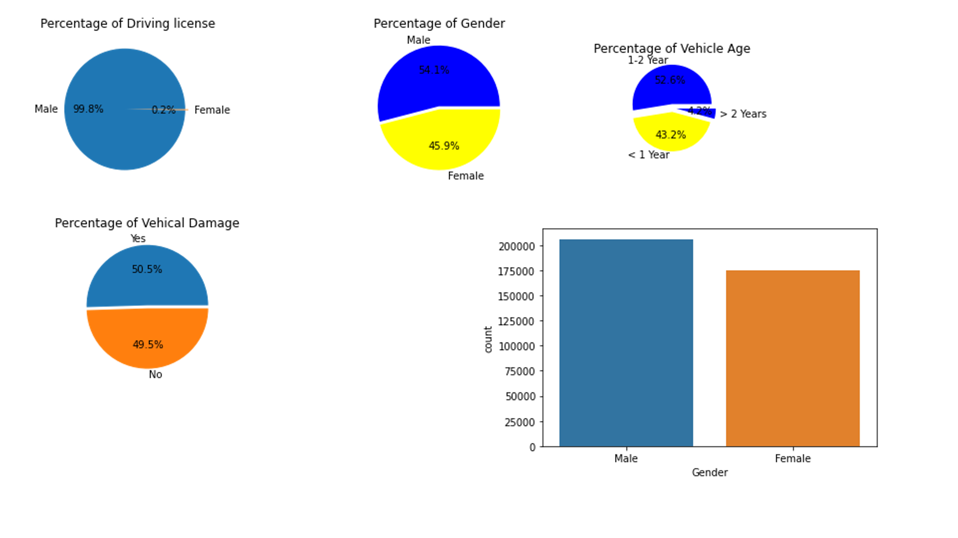

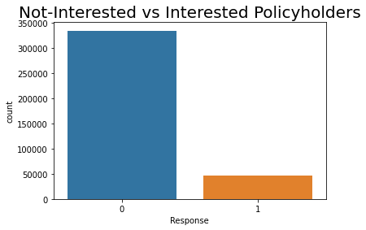

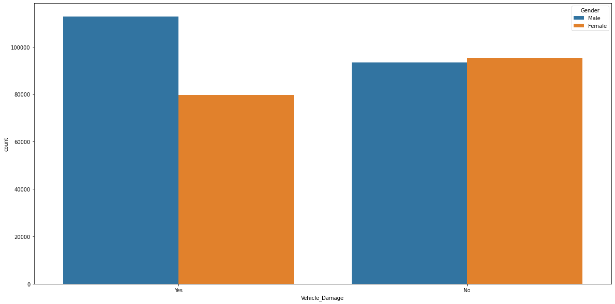

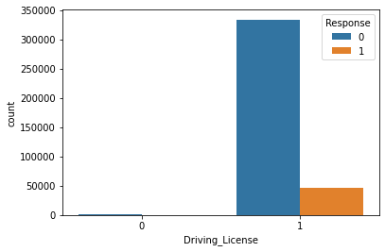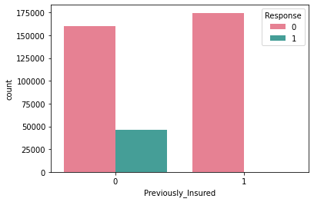

**Vehicle age Vs Response**

Vehicle age between 1-2 years customers are more interested in insurance than other two.

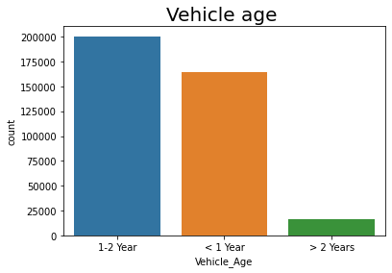

AGE VS RESPONSE

* We can see that Ages below 30 are not more interested in purchasing vehicle insurance may be because lack of experience and maturity levels.
* People who are above 30-55 are more likely to be interested.
* After 50 the lines are declining that’s means age above 50 are less interested.

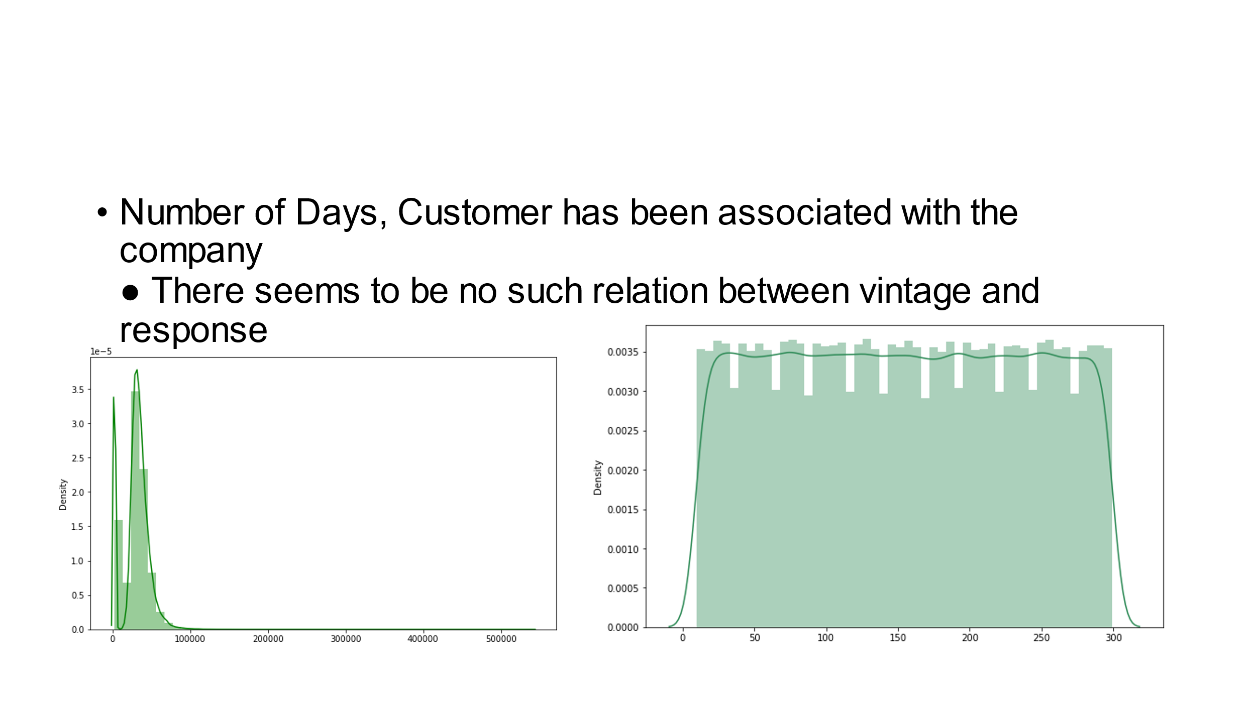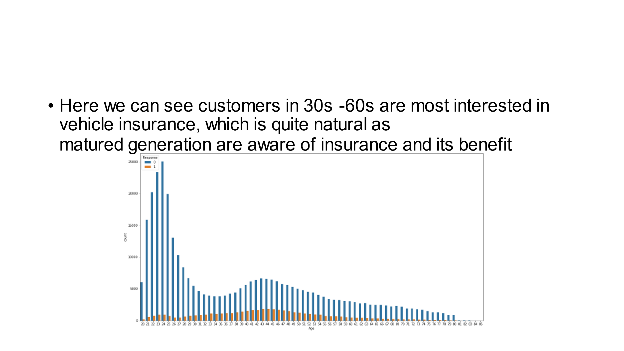



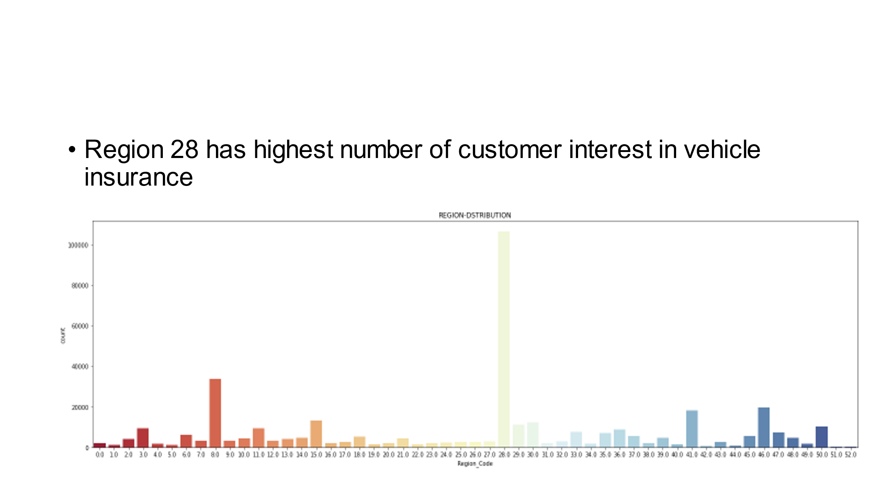

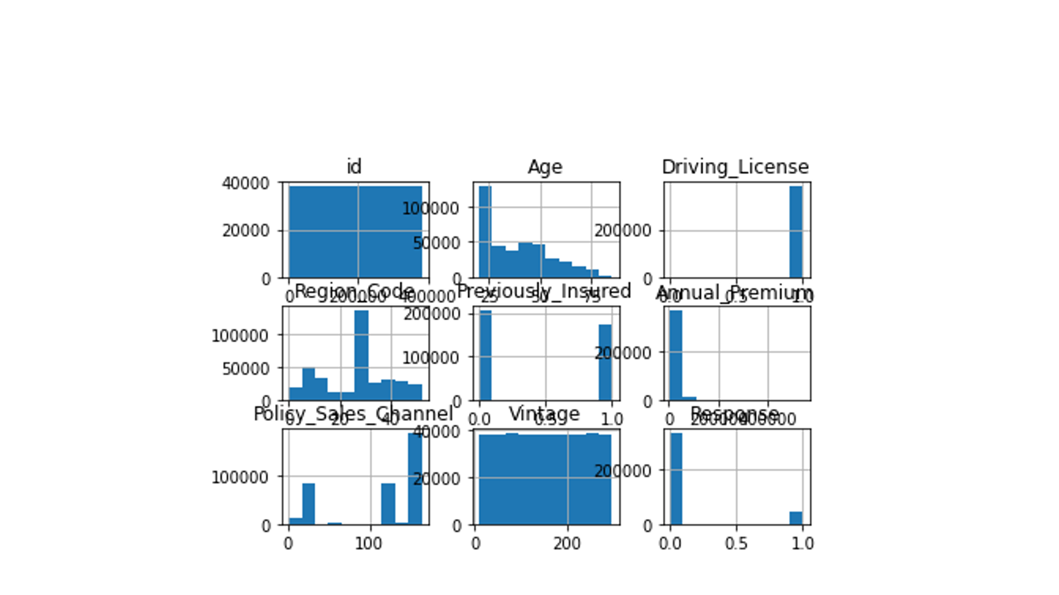

* **Outliers handling**

Checking outlier in the dataset because Outliers is also something that we should be aware of. Why? Because outliers can markedly affect our models and can be a valuable source of information, providing us insights about specific behaviours. Outliers is a complex subject and it deserves more attention

We have a lot of outliers in our Premium column, driving license and response column but due to less business knowledge we are not removing any outliers

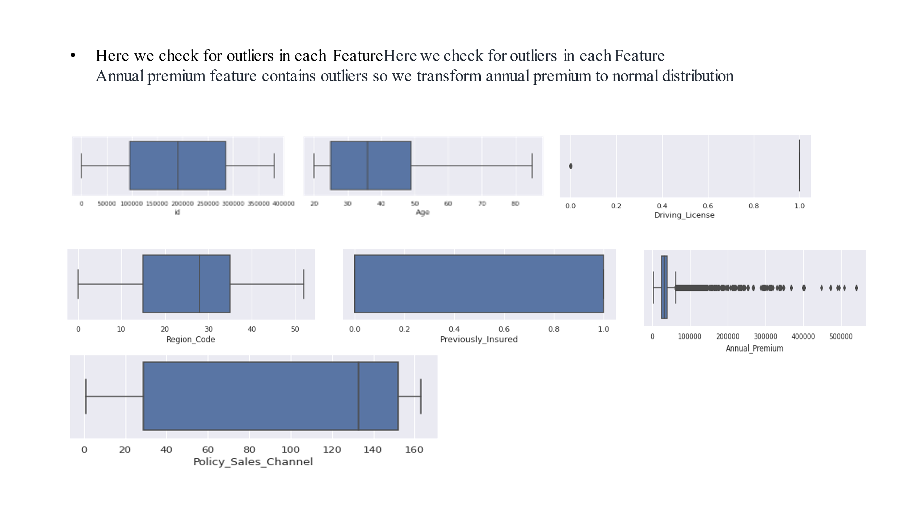

### Model implementation:

***After we performed feature scaling and one hot encoding on respective features we moved next step i.e. applying a machine learning model to predict a class for a new observation.***

***In this project, we have used three models-***

### Decision Tree model

1. **Logistic Regression**

### Random Forest model

* Train –Test Split  
  ● After applying Smote to balance the data, we now fit dataset to train- test split for training and testing  
  purpose(model evaluation).  
  Model Selection  
  M odels we will be using here are:  
  ● Logistic Regression  
  ● Decision Tree  
  ● Random Forest  
  ● XGBClassifier

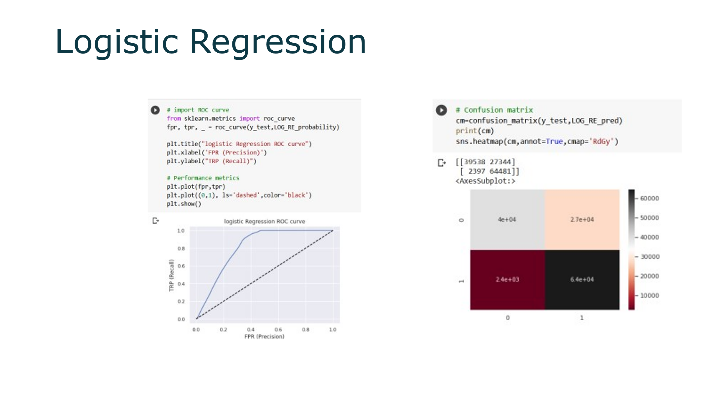

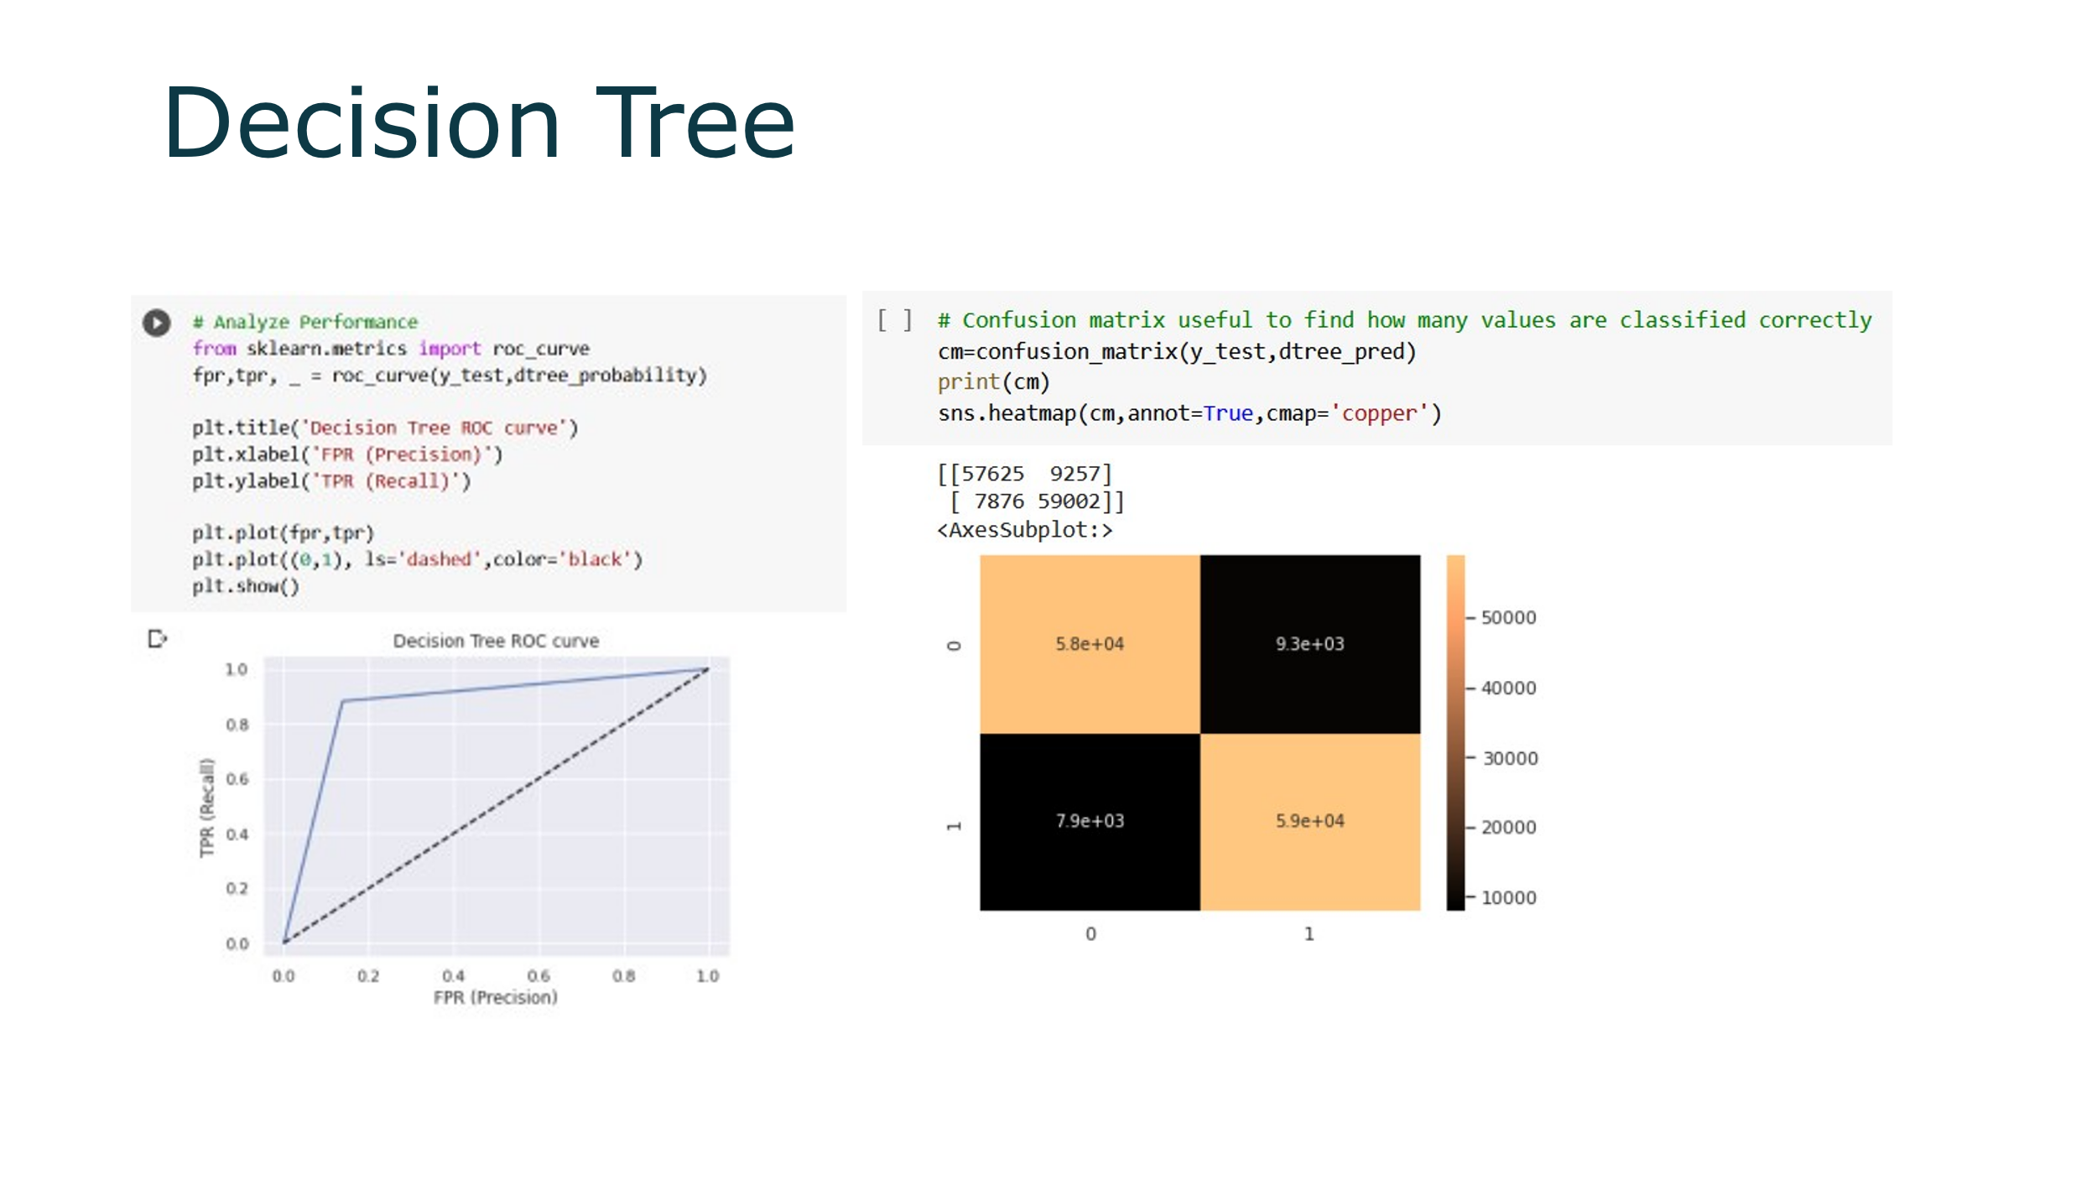

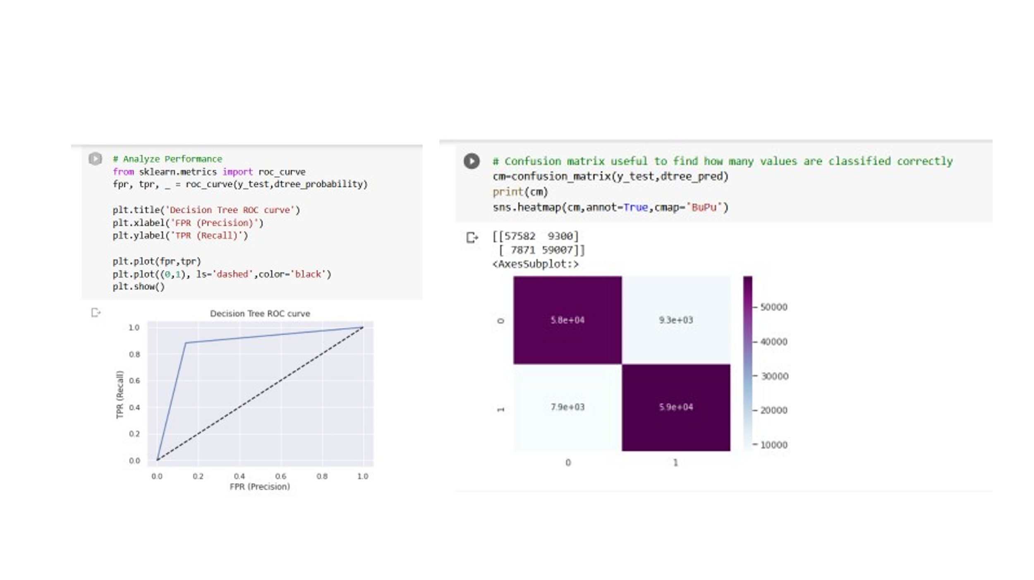

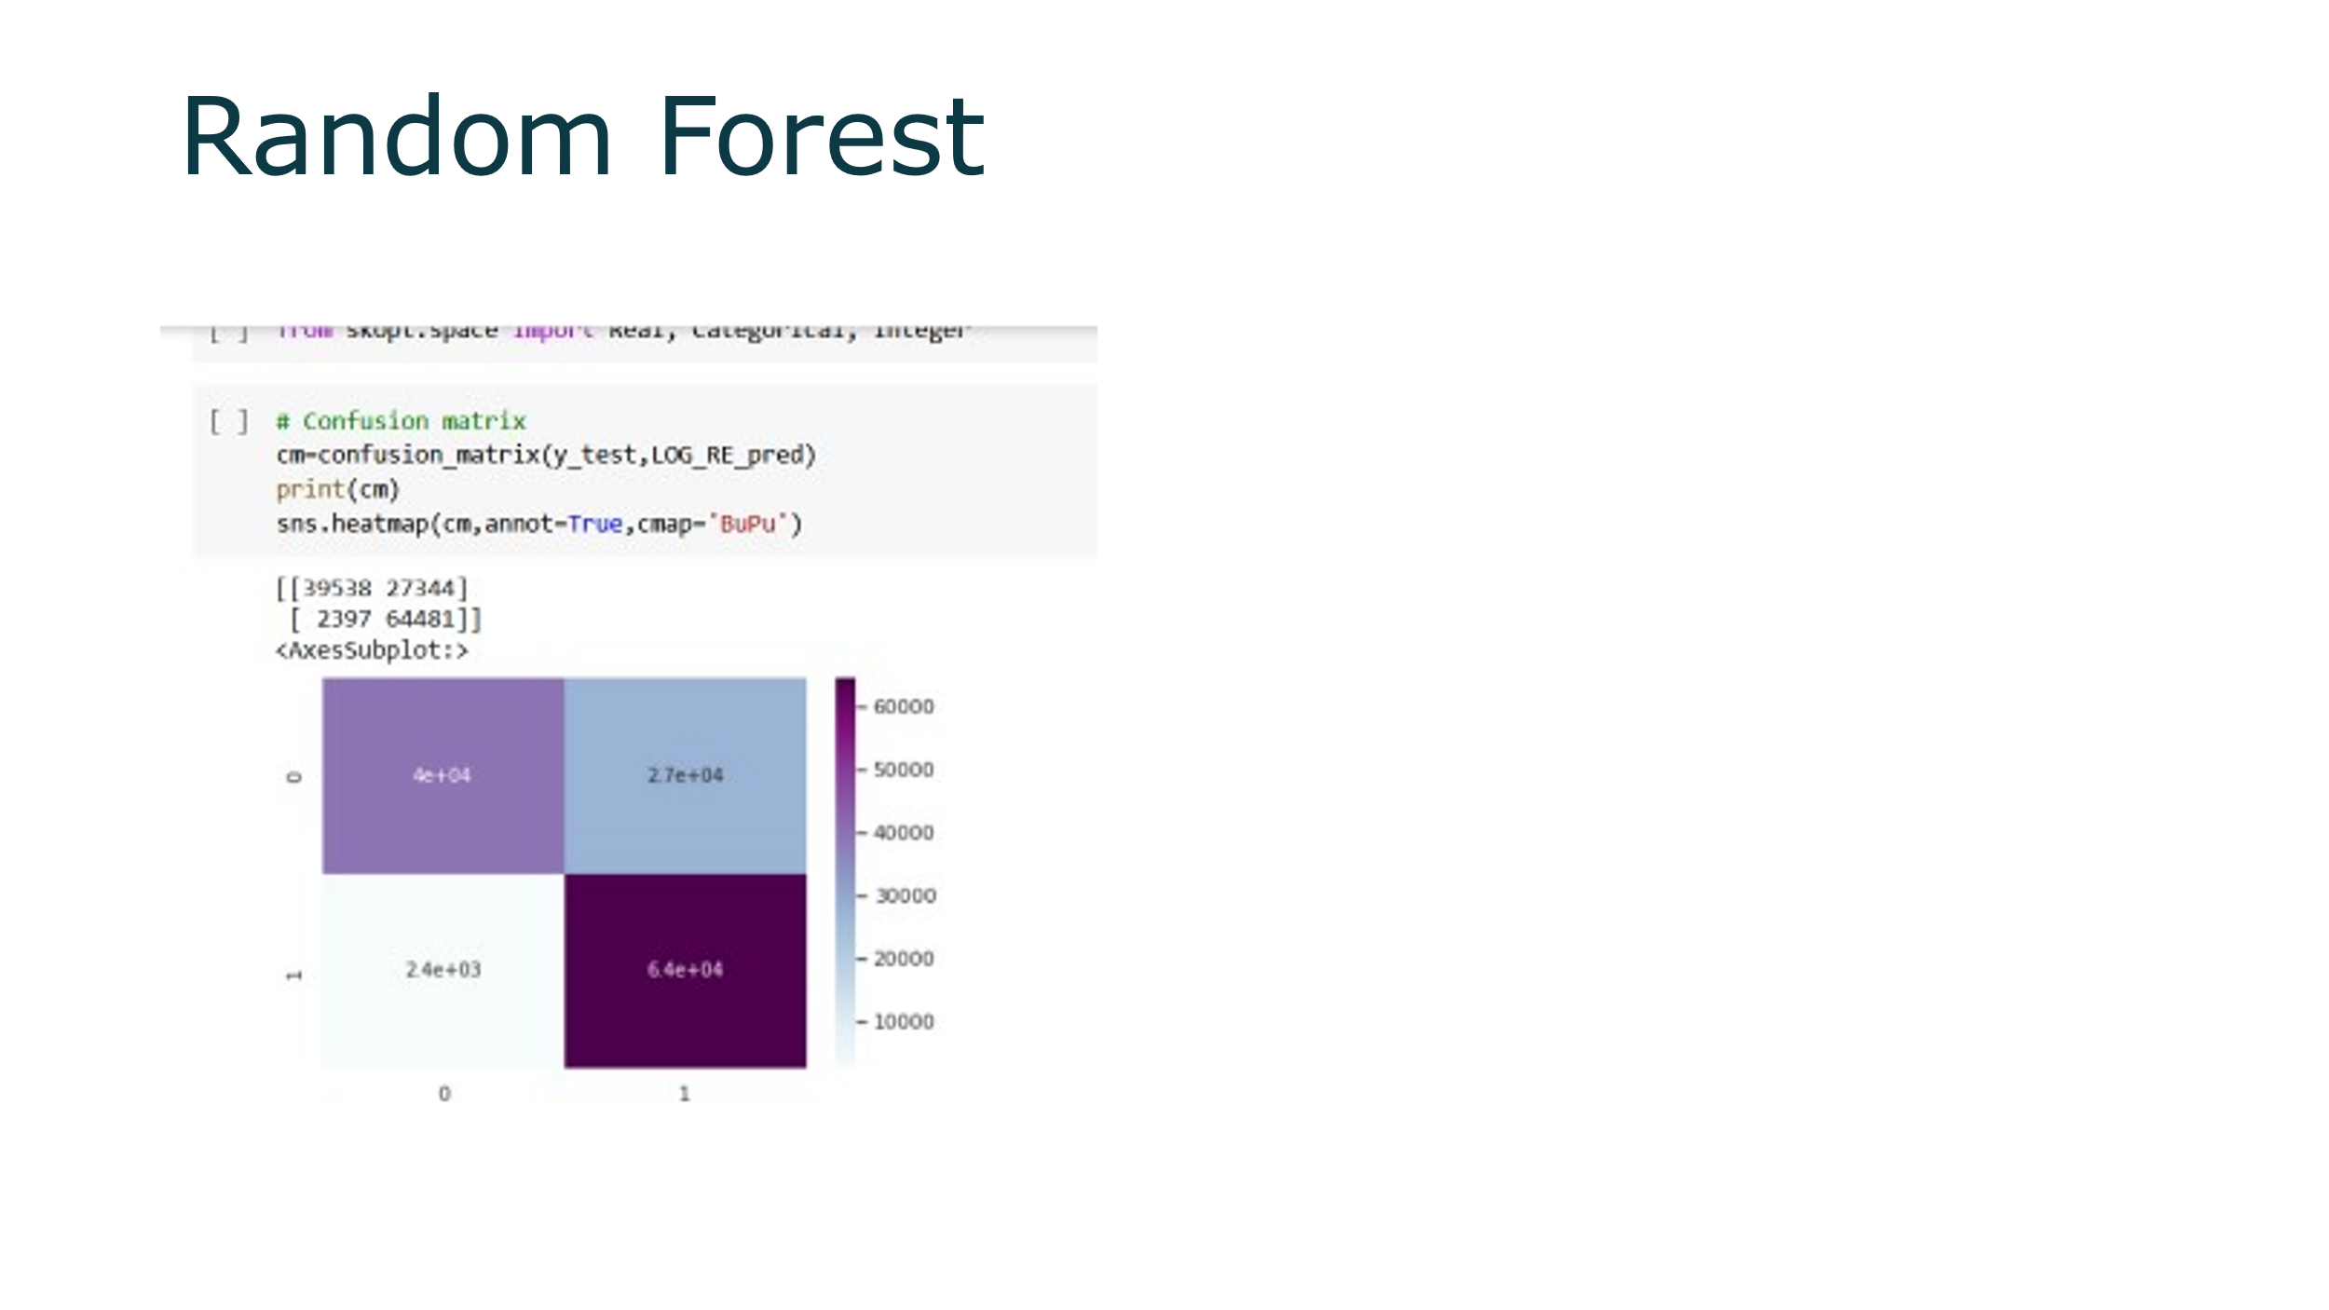

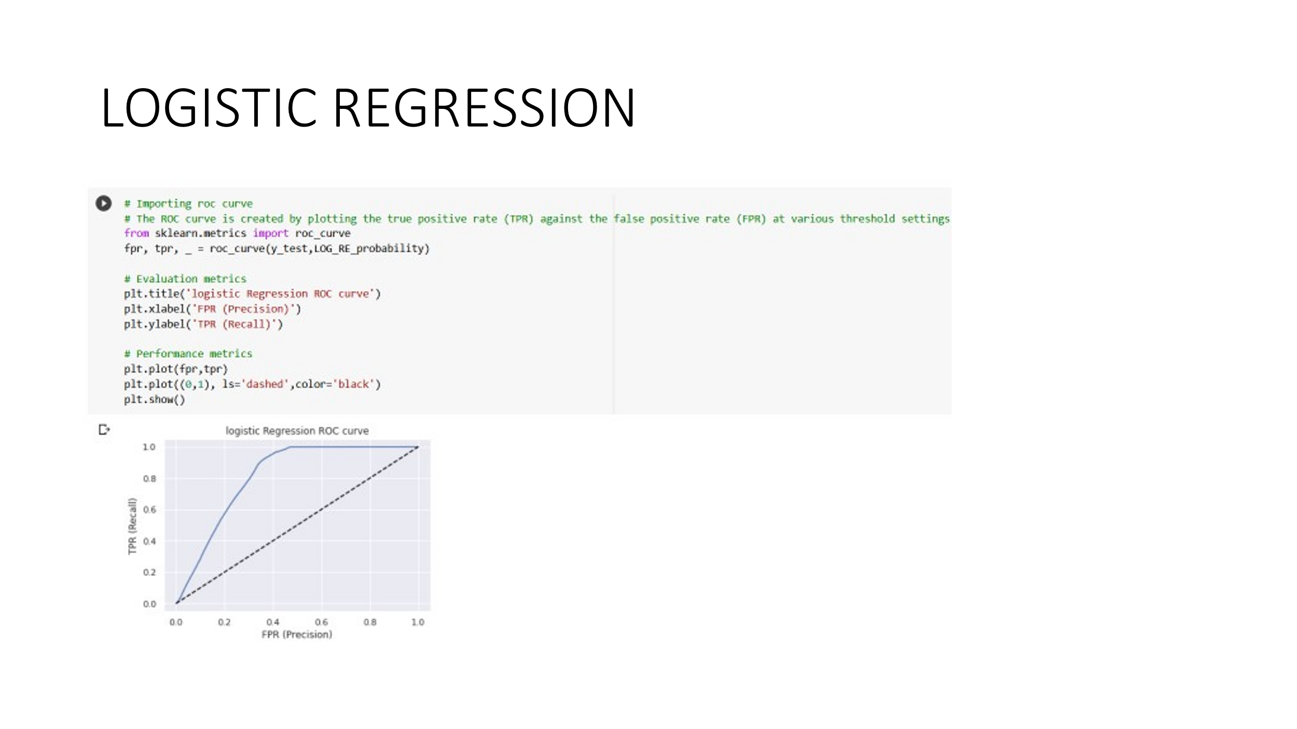

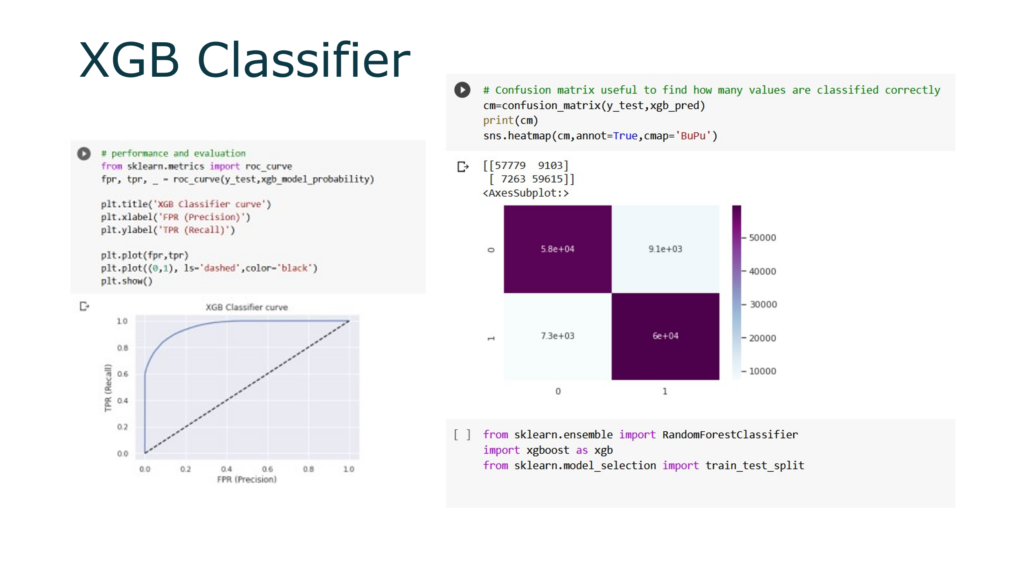

# **Conclusion:-**

* Due to the Response variable's value 1 being much lower than its value 0, the provided dataset is an imbalanced dataset.
* Compared to their female counterparts, male consumers own a little bit more vehicles and have a higher likelihood to get insurance.
* Customers between the ages of 30 and 60 are the most likely to get insurance whereas Vehicle insurance is not interesting to anyone under the age of 30. The lack of involvement, a lack of knowledge about insurance, and possibly the lack of expensive vehicles are potential causes.
* Customers with driving licenses are more likely to purchase insurance
* Compared to consumers with vehicles less than one-year-old, those with vehicles between one and two years old are more interested in purchasing insurance.
* Due to their personal experience with the costs associated with vehicle repairs, customers with vehicle damage are more likely to purchase insurance.
* The variable such as Age, previously insured, and Annual premium is more affect the target variable.

# We used different types of algorithms to train our model like Logistic Regression, Random Forest model, Decision tree, and XGB Classifier. And Also, we tuned the parameters of the XGB Classifier and Random Forest model. Comparing the model on the basis of precision, recall, accuracy, and F1 score we can see that the XGB Classifier model performs better. Even comparing the ROC curve XGB Classifier performed better because curves closer to the top-left corner indicate